* Features to be Integrated:
  + Adjustable Handle Height
  + Breaking Mechanism
  + Changing seat form (crib to seat)
  + Free swivel wheels (To be discussed)
* Adjustable Handlebar:
* 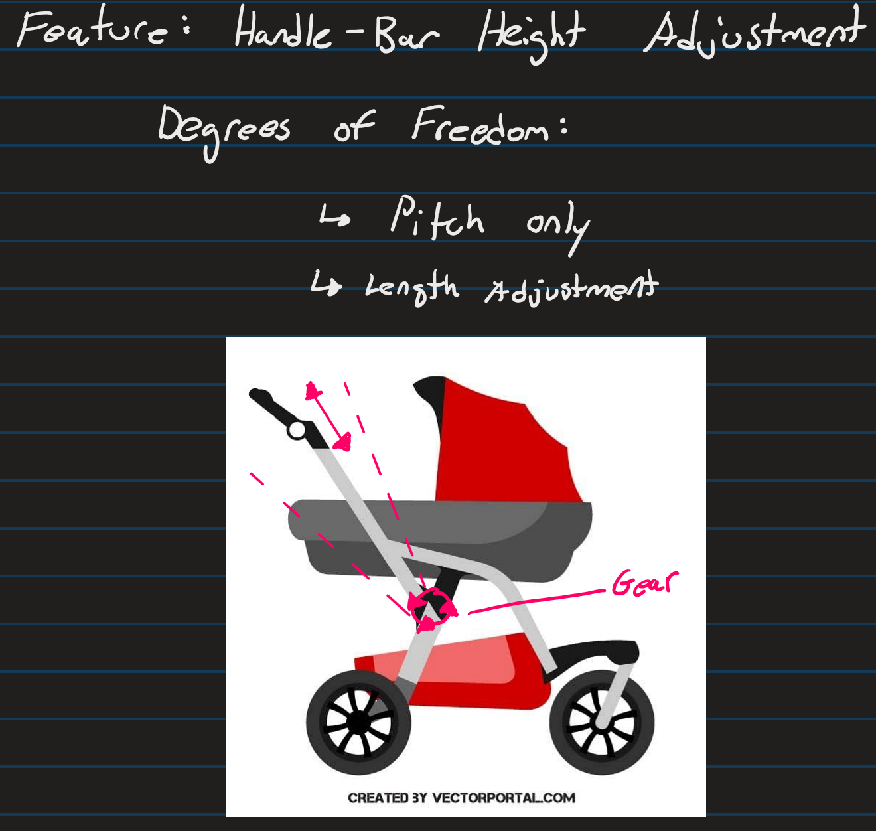
* Image source: [BABY STROLLER.ai Royalty Free Stock SVG Vector and Clip Art (vectorportal.com)](https://vectorportal.com/vector/baby-stroller.ai/19958)
* [Ideal stroller](https://www.amazon.ca/INFANS-Landscape-Convertible-Reversible-Adjustable/dp/B0B9MGC1MD?th=1)
* **Issues with this design:**
* 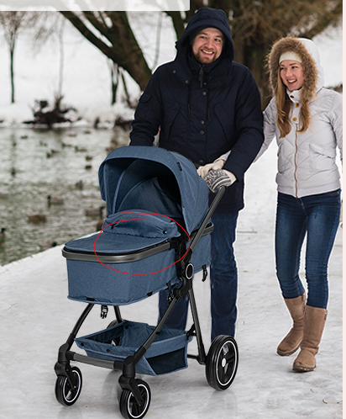 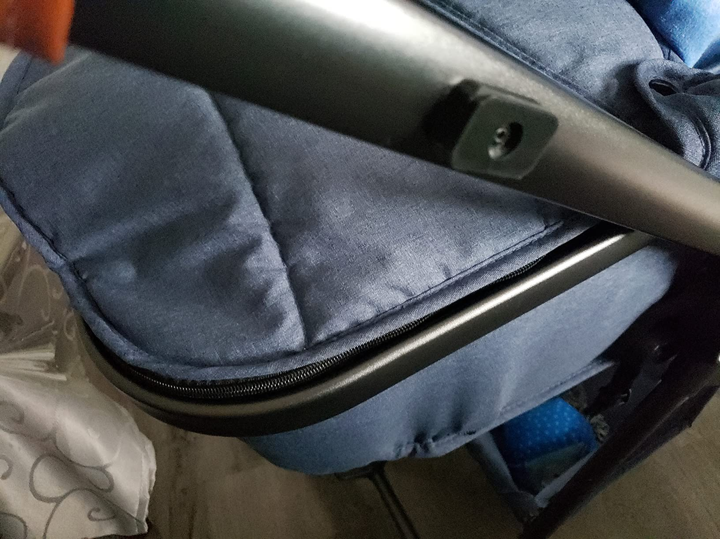  
  1: Zip to close can nip baby’s fingers, unsafe
  + Alternative: Velcro, slide on cover
* 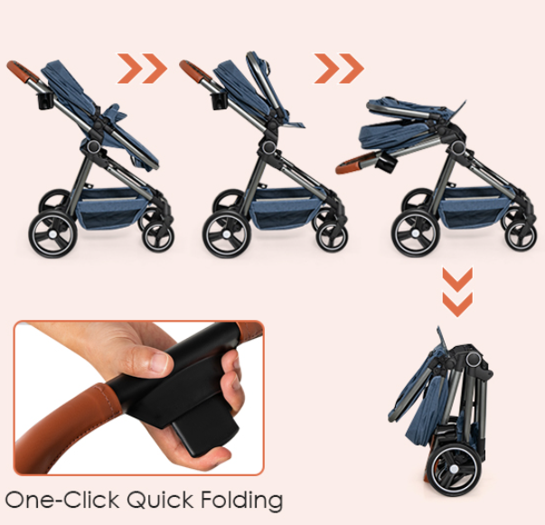  
  2: One-click is too easy to accidentally press, unsafe
  + Alternative: Multi-step button to avoid accidental press  
    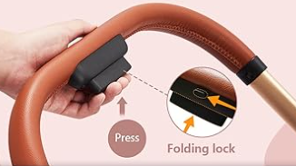
* **Benefits to design:**  
   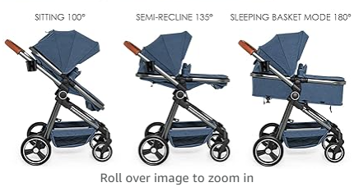  
  1: Multiple seat types and angles
* 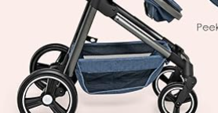  
  2: Good amount of storage space at
*   
  3: Good folding method (besides button)
* 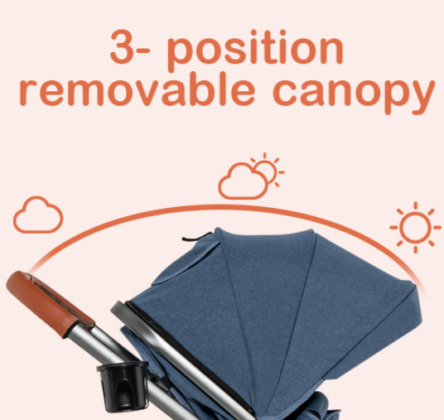  
  4: Good canopy